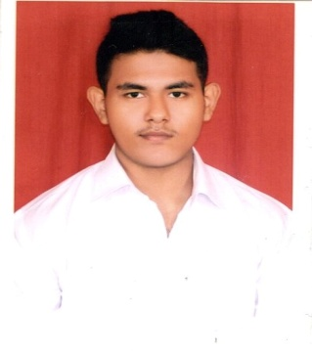
SUBHRADEEP SEN
Subhrasen26@gmail.com
C/18/1, Garia Park, Kolkata-700084
9874815818
Father’s name: Goutam Sen
Objective
I am looking for an organization which will help me learn, grow and diversify to the stream and sector of my interested department and will also help me to reach the pinnacle of success in my near future.
qualifications
`
YEAR | INSTITUTE | MARKS
2013-2014 | institute of hotel management  Kolkata | 1st sem : 68.69%  2ndsem : 67.61%  3rd & 4th sem : 72.16%  5th sem : 71%  6th sem : 67%
2012 | g.d Birla centre for education | 74.15%
2010 | Hartley’s high school | 64%

Experience
TAJ BENGAL KOLKATA 34B, Belvedere Road Alipore, Kolkata: 700027
Had an industrial exposure at the TAJ BENGAL KOLKATA for 4 months (from 9th December 2013-5th April 2014).This training has not only helped me to gain immense knowledge about the industry but has also helped me to decide my career option for my future.
TRIDENT HYDERABAD (OBEROI GROUP OF HOTELS)
Currently I am working as a reservation associate with Oberoi group of hotels and have an in depth knowledge about Front Office operations, Reservation Operations and Revenue Management tools and systems.

Skills

- Competent at managing responsibilities in a fast paced and high volume atmosphere.
- Enthusiastic to listen and always try to learn from the capable.

- Skilled at building positive relationship and communicating well with patrons of socio economic background.
- I strongly believe in achieving my goal through team work.

Responsibilities and Specialities
- Competition Analysis : STR and Travel Click
- Online Rate management and Demand based pricing
- In depth knowledge about Market Segments.
- Managing group reservations and handling blocks.

hobbies
- I like listening to songs and watch movies.
- I like to travel to various places, explore new things and being a part of different cultures.
- Experimenting with different recipe and also try and add new flavours to them.
- Also a fitness enthusiast.

achievements
- Participated at Cocktail making competition organised by the hotel and finished as a runner up for the same.
- Also was a active member of drama team at G.D BIRLA CENTRE FOR EDUCATION and participated in various competition.

languages known
English, Hindi

declaration

I hear by declare all the above written information is correct and complete to the best of my knowledge and belief.

DATE:
SIGNATURE

